FSG Warehouse Management System

# Logging In

The first time you access the new WMS you will need to set a password

You will see a login screen

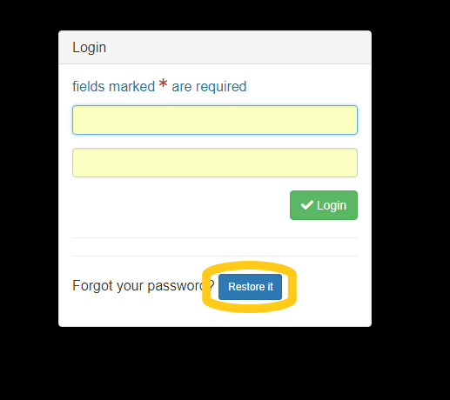Click the blue “Restore It” button at the bottom of the form

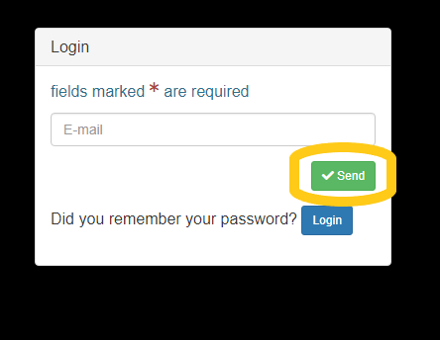This will bring up the Password Reset form

Fill in your email address and click the green “Send“ button.

If your email is in the system you will receive an email with a link to click for resetting your password. The link is a timed link and will expire after 24 hours. You can always click to receive a new link after this time.

When you click on the link in the email you will see the password update form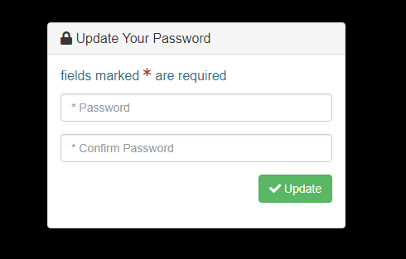

You can choose your own password, but please try and use a complex one (involving at least 2 of uppercase letters, lowercase letters, numbers and symbols and a minimum of 8 characters long)

Retype to confirm your password and click the green “update” button.

If you are successful, you will see the success message and will be able to click on the link to use your new password to log in

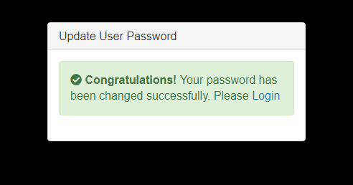

Once logged in, you can update your profile – change name, password and icon – by clicking the down arrow next to the user icon at the top right of the screen

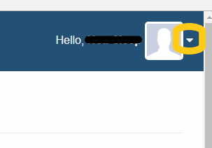

The logout link is in this menu too.